https://github.com/Gregory-Luyckfasseel/Emerald-Wallet-Mockups
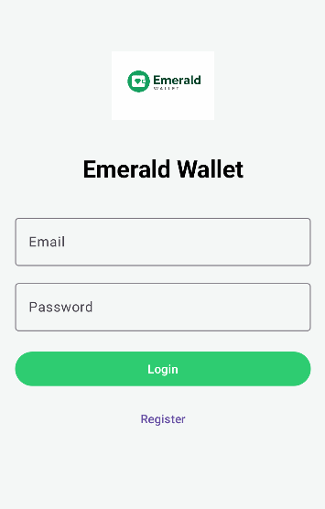
Login screen: This is the entry point to the application. This screen allows users to login by filling in the email and password fields which is then authenticated against the accounts already created for application. For new users, the screen features an option to register an account through a clean, branded interface.
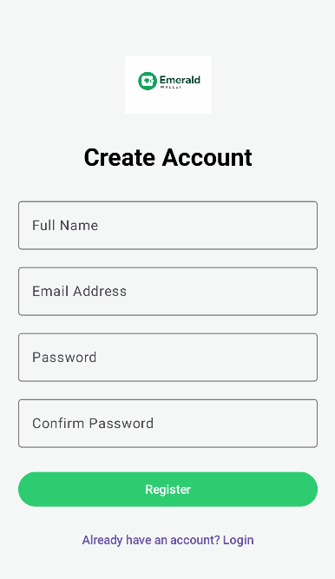
Register screen: This screen allows users to create an account through a structured form that captures their full name, email address, and password. If the user already has an account, they can easily be redirected back to the login screen.
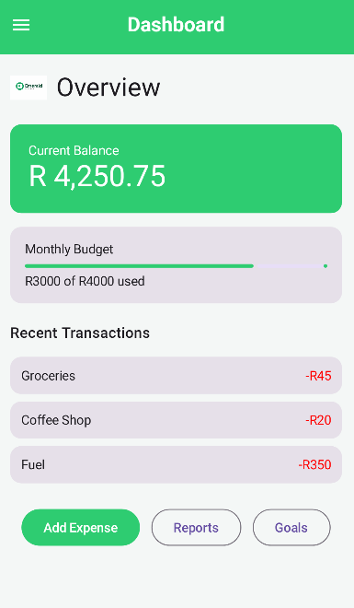
Dashboard screen: This screen is the central hub of the application which shows a quick view of the user’s financial health including their current balance, a progress bar of their monthly budget and a list of recent transactions. Below are quick action buttons that direct the user to other sections of the application.
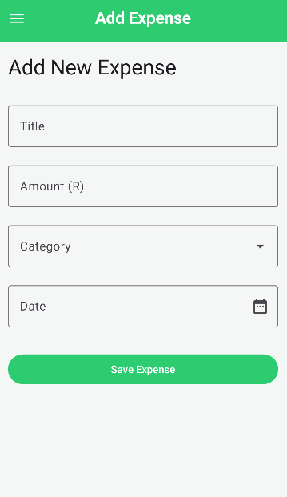
Add expense screen: This screen serves for the user to record transactions. It includes fields for the title of the transaction, the amount, category of spending and the date of the transaction.
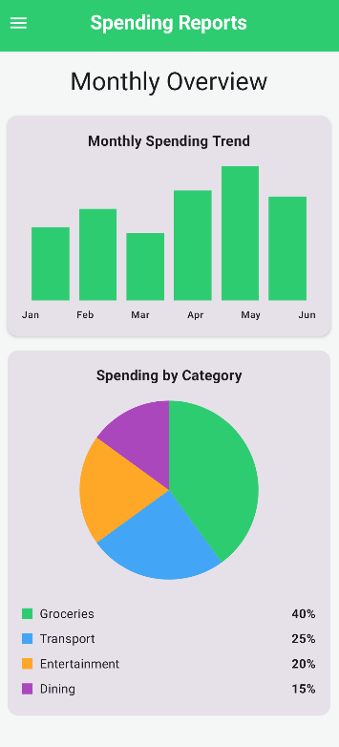
Reports screen: The reports screen utilises a bar graph and pie chart to help users visual their spending and analyse it by showing how much a user is spending in each category so they can identify where their money is being spent.
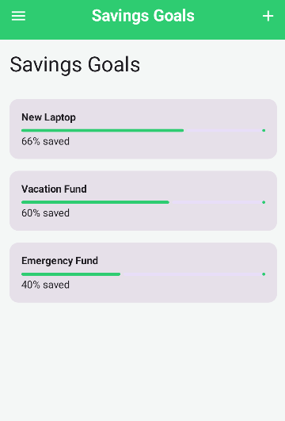
Goals screen: This is the users screen for keeping track of long-term spending goals. It displays the progress that the user has made in saving towards their active goals by using a progress bar for the user to easily visualise how much more they need to save. Each goal may be clicked on to edit them and the button on the top right is used for adding a new goal to the list.
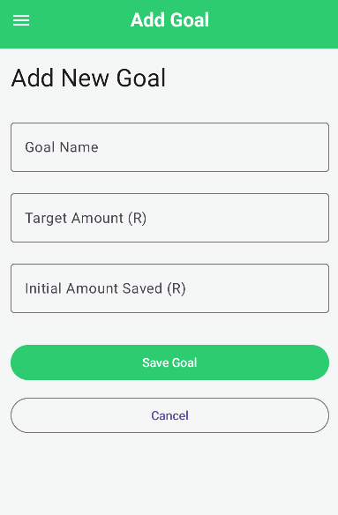

Add goal screen: This screen is used for users to initialise new milestones for them to reach. The screen has fields for the goals name, total amount and the amount the user is initialling putting towards the goal, this information sets the foundation for tracking the goal in future.
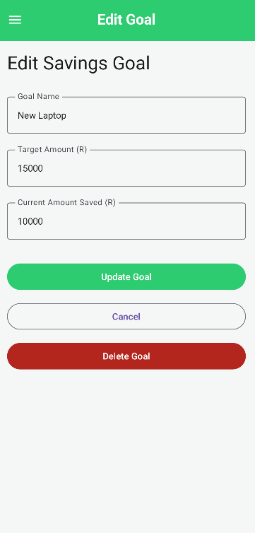
Edit goal screen: This extension of the goals screen allows the user to record progress they are making in saving towards a goal, adjust the name or target amount of the goal or delete the goal entirely.
User flow diagram:
